Identifying Factors Associated with Eating Disorder Concealment Among Males in Southeast Asia Using Computational Text Analysis
By Shalini Roy – Shiv Nadar Institute of Eminence, B.Sc Biotechnology

- Introduction

Eating disorders are serious, psychological illnesses, that affect physical, mental, and social
wellbeing. It is not a condition of atypical food intake but is also closely related to how the
disorder affects the physical health, psyche and social life of a person. Eating disorder is also
symptoms of deeper psychological issues like anxiety, control, self-esteem, emotional pain,
identity issues, etc. They can affect people of any age, ethnicity, race or body type; although
society tends to generalize and create stereotypes that point to certain groups.
People often judge or misunderstand eating disorders, but they are actually much more
common than most people realize. According to the National Eating Disorders Association
(NEDA), around 8.6% of females and 4.07% of males experience an eating disorder in their
life.

Between 1990 to 2021, the global prevalence of eating disorder has increased from 300.73 to 354.72 per 100000 population. High SDI (socio-demographic index) regions bore the greatest burden, with countries like Australia and Monaco reporting the highest rates. Women had an 85.89 % higher prevalence than men, but men showed faster increases.
Eating disorder can cause irreversible damage including cardiovascular problems, bone loss, gastrointestinal distress, fertility issues, and even death. It can also cause irreversible psychological trauma. Eating disorders are frequently associated with psychiatric comorbidities, including depression, anxiety, and suicidal ideation.

The American Psychiatric association published DSM (Diagnostic and Statistical Manual of
Mental Disorders). It is the official handbook to identify, diagnose and treat mental
disorders. The older version of DSM is known as DSM IV which is now replaced by DSM 5.
DSM 5 integrates decades of new neurological and psychological research, shifts toward
evaluating symptoms on a spectrum rather than a strict yes or no.

The different kinds of eating disorder include the following: -

Anorexia nervosa is characterized by severe food restriction and significantly low BMI. Bulimia nervosa involves binge eating followed by compensatory behaviours such as vomiting or excessive exercise, occurring at least weekly for three months. Binge-eating disorder (BED) features excessive food consumption without compensatory behaviours and is often accompanied by emotional distress. Avoidant/Restrictive Food Intake Disorder (ARFID) involves a lack of interest in food due to sensory issues, leading to nutritional deficiencies. Other specified eating disorders include atypical anorexia nervosa and low frequency bulimia, while pica refers to the persistent consumption of non-food items.

Research indicates that eating disorders (ED) affect men as well as women, despite the stereotype that they are primarily female illnesses. Men often experience body dysmorphia, leading to unhealthy bulking and cutting cycles, which standard assessments may not recognize due to a lack of sensitivity to male symptoms. Many men with ED may have normal BMI levels, thus not receiving a diagnosis despite their condition. The prevailing notion that ED is a feminine issue leads to underreporting in surveys and bias in diagnosis, as societal expectations of masculinity create stigma around the disorder. This results in significant diagnostic and selection biases in the representation of male ED cases.

Male eating disorders in South East Asian communities remains invisible due to cultural
difference of masculinity, toxic stereotypes, and the misconception of the eating disorder to be a ‘Western problem’. This prevents early diagnostics and treatment and causes a lot of substantial burden of undetected and untreated illness. Men are heavily undiagnosed in South East Asia due to cultural biases and stigma in the region. Although the prevalence rates for eating disorders in men remain statistically low, cases are rising. The mortality rates of men for eating disorders have significantly risen compared to women. This is not due to the fact that the illness is rare, many cases of eating disorders in South East Asia goes unrecorded due to social stigma, lack of awareness and limitations to healthcare facilities.

Males in South East Asia often conceal eating disorders due to deeply ingrained societal stigmas, traditional gender roles, and the misconception that eating disorders are exclusively a "Western female" issue. Traditional masculine norms emphasize emotional control and strength; thus, discouraging disclosure of psychological illness. This concealment prevents them from seeking help, leading to severe underdiagnosis in the region and delay in help-seeking.

- Aim

Although many studies have examined eating disorders among males and investigated factors such as stigma, masculinity, and body image. Comparatively few studies have actually discussed the reason and factors contributing to concealment of eating disorders specifically in South East Asian males. Thus, this study aims to identify and synthesize socio-cultural and gender-related factors that contributes to the concealment of eating disorders. Concealment is associated with psychosocial factors; thus, I am building computational evidence for this claim. This is done through a computational text analysis of 50 papers. Computational text analysis, exploratory data analysis and natural language processing allows us to identify recurring linguistic patterns and contextual relationships across large collections of published literature.

Due to limited availability of studies focusing exclusively on Southeast Asian male populations, this study also delves in papers from western countries to provide a broad understanding and comparison of the factors related to eating disorder concealment.

- Methodology

  - Study Design
This study employed computational research on research papers (n = 50) combining manual thematic analysis, exploratory data analysis and natural language processing to understand the factors that contribute to the concealment of eating disorder among males in South East Asia. Statistical Analysis and computational analysis were performed to correlate between the common factors observed in papers.
  - Study selection
50 research paper was collected and extracted into an excel file from various sources including PubMed, SpringerLink, Google Scholar and other academic databases. Most of them focused on eating disorders in males (in South East Asia and other regions) The excel database was then cleaned and exported to Google Colab (python 3) for further analysis. Data management was carried out using Pandas, while Matplotlib was used for data visualisation. Natural Language Processing was conducted using the Natural Language Toolkit.
  - Data extraction
Data was extracted in excel file and included author, source , country, gender, type of study, year of publication, title, abstract, factors behind concealment, personal notes, reported prevalence, measurement tool, type of eating disorder, age group, sample size and region of study.
  - Manual Coding
Each study was reviewed and coded for five predefined factors: (concealment, shame, family, masculinity, help-seeking and stigma). Binary values of 0 and 1 were assigned. 1 indicated the presence of a theme and 0 indicated its absence. The coded dataset was subsequently used for descriptive statistical analysis and correlation analysis.
3.5 Exploratory Data Analysis (EDA)
Exploratory data analysis was performed to get a greater insight on the descriptive studies before doing the computational analysis. Visualisations were generated to examine publication trends, geographical distribution, study design, measurement instruments, eating disorder categories, thematic frequencies, and relationships between coded themes. Correlation analysis was conducted to identify patterns of the factors and visualization of factors associated with concealment was also performed.
  - Computational text analysis for Identifying Concealment-Associated Factors
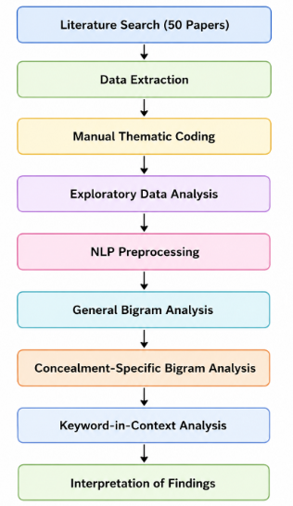
Computational text analysis was performed using Natural Language Processing (NLP). Unlike manual coding, which identifies predefined themes, NLP enables the identification of recurring linguistic patterns and contextual relationships within textual data. Two levels of study were conducted (i) Analysis of the entire 50 papers from including regions that are not from South East Asia (ii) Analysis of specifically papers from South East Asia. These were then compared consequently
  - Comparative Bigram Analysis
Bigram analysis was conducted using the NLTK library to identify frequently occurring two-word combinations. Similarly, bigram was developed for (i) 50 papers from including regions that are not from South East Asia and (i) (ii) Analysis of specifically papers from South East Asia and then compared. Here, the abstracts was taken into consideration only.
  - Keyword-in-Context (KWIC) Analysis of Concealment-Related Themes
Keyword-in-Context (KWIC) analysis was performed on the concealment-specific corpus to examine the contextual usage of major themes identified through manual coding and bigram analysis. Here, the abstracts was taken into consideration only.
Figure 1 overview of methodology

- Results - Computational Evidence for Factors Associated with Concealment

4.1. The figure of the descriptive analysis of the papers is given below and interpreted as follows:
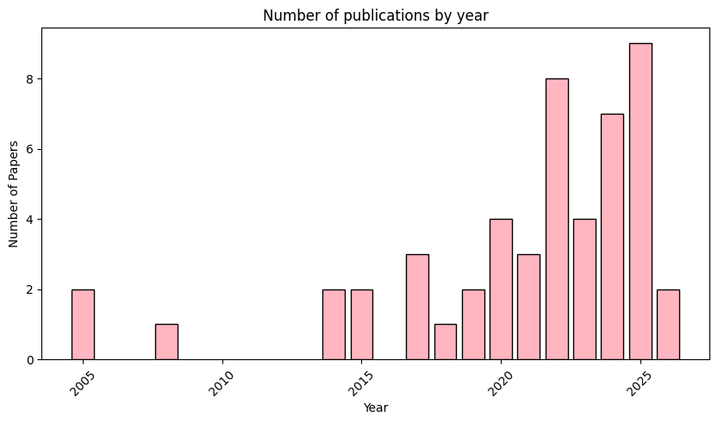
4.1.1 Publication year
Figure 2 Publication year in dataset
From this graph we notice very few publications before 2015. The publications start increasing after 2016. There is a sharp rise in the publications after 2022, with 2025 recorded having the highest number of publications. Signifying advancement of research in this area.

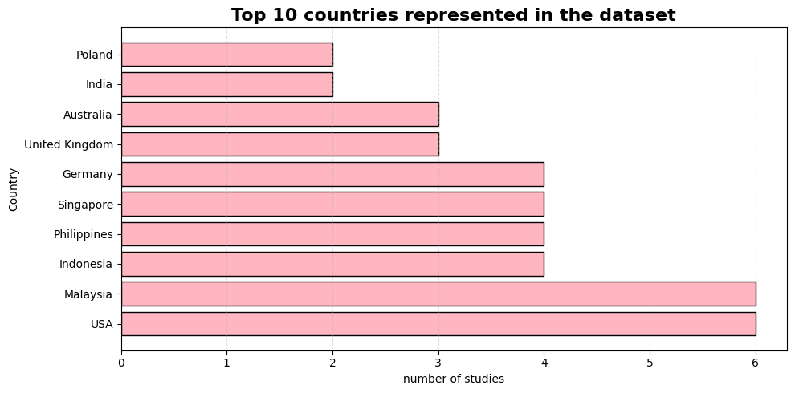
4.1.2 Countries
Figure 3 Countries in dataset
From this we note that Malaysia and USA had the highest number of studies (n = 6 each), followed by Indonesia, Singapore, the Philippines, and Germany (n = 4 each). Signifying a substantial representation.

4.1.3 Regions
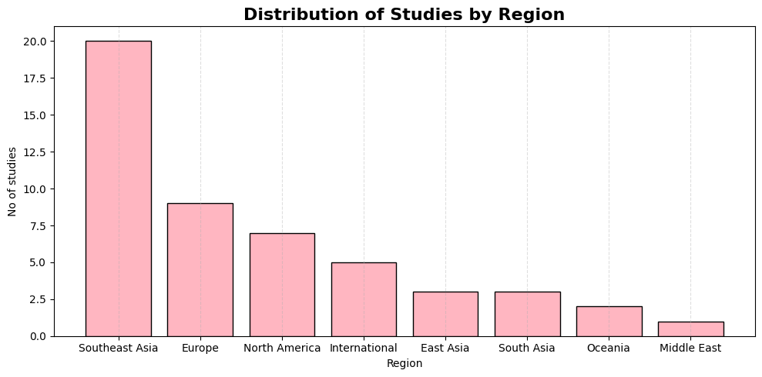
South East Asia is approximately majority (39.2%, n = 20) of the dataset, Europe was the second most represented region (n = 9; 17.6%), followed by North America (n = 7; 13.7%). International or multi-regional studies comprised 5 studies (9.8%), while East Asia and South Asia each contributed 3 studies (5.9%). Oceania contributed 2 studies (3.9%), and the Middle East was represented by 1 study (2.0%).
Figure 4 regions in dataset
The predominance of studies from Southeast Asia reflects the regional focus of the present review while also demonstrating that relevant evidence has emerged from multiple geographical contexts.
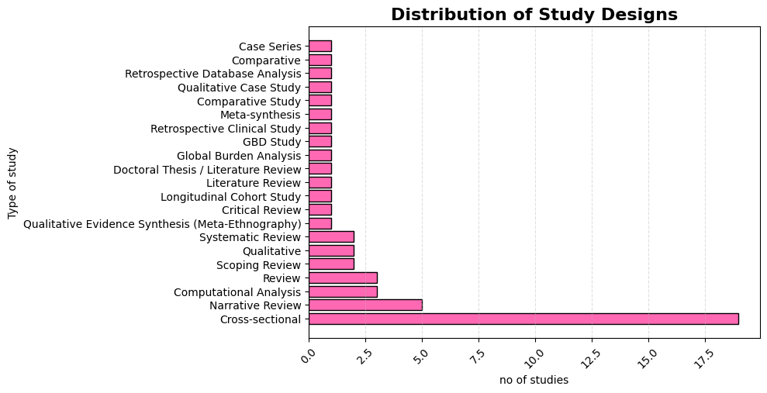
4.1.4 Regions
Figure 5 distribution of study designs
The dataset included a wide range of studies. The cross sectional method of study was the largest category (n = 19). Followed by Narrative reviews (n = 5) and computational analyses (n = 3). Review articles and scoping reviews each contributed 3 and 2 studies, respectively, while qualitative and systematic review methodologies accounted for 2 studies each

4.1.5 Categories of Eating disorder
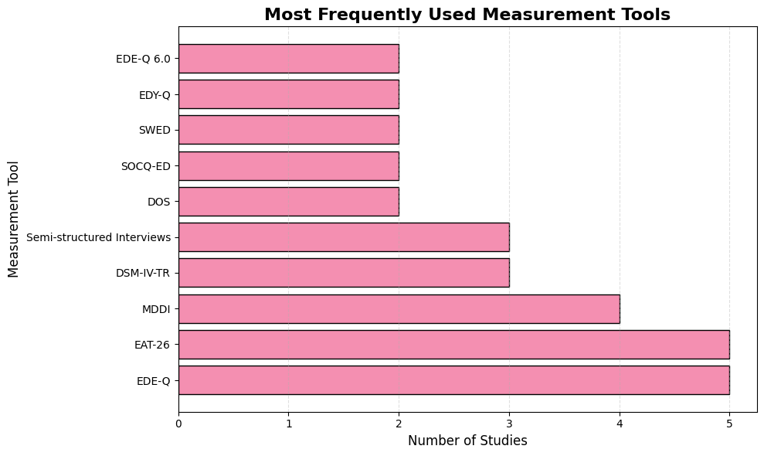
Here we notice that Eating Disorder Examination Questionnaire (EDE-Q) and the Eating Attitudes Test-26 (EAT-26) were the most frequently used instruments (n = 5 each). Followed by The Muscle Dysmorphic Disorder Inventory (n = 4), reflecting the increasing focus on muscularity-oriented body image concerns in male populations. Both the DSM-IV-TR diagnostic criteria and semi-structured interviews have been cited in three studies, showing that both the standardized approach to diagnosis and qualitative assessment techniques are still valuable in research. Some of the other methods used in more than one study include Drive for Muscularity Scale (DOS), Stanford-Washington University Eating Disorder Screen (SWED), Sociocultural Attitudes Questionnaire for Eating Disorders (SOCQ-ED), EDY-Q, and EDE-Q 6.0.
Figure 6 Measurement Tools
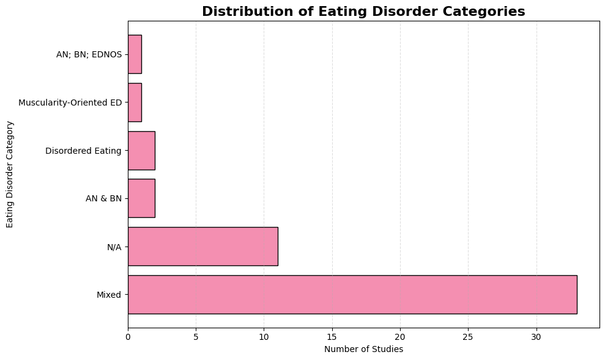
4.1.6 Distribution of Eating disorder Categories
Figure 7 Distribution of Eating disorder Categories
The majority of the studies (n=33) dealt with mixed eating disorder categories, showing that most of the researchers conducted studies on eating disorders in general and not on specific types of eating disorders. 11 studies had no specific eating disorder categories (N/A). Very few studies were conducted on specific eating disorders, namely, only two studies were done on anorexia nervosa and bulimia nervosa together, two on disordered eating, and one each on muscularity-oriented eating disorders and AN, BN and EDNOS. This represents that most researchers prefer to do a mixed category of eating disorders. One of the factors may be the fact that most males feel uncomfortable to take part in these studies, again due to factors related to concealment.
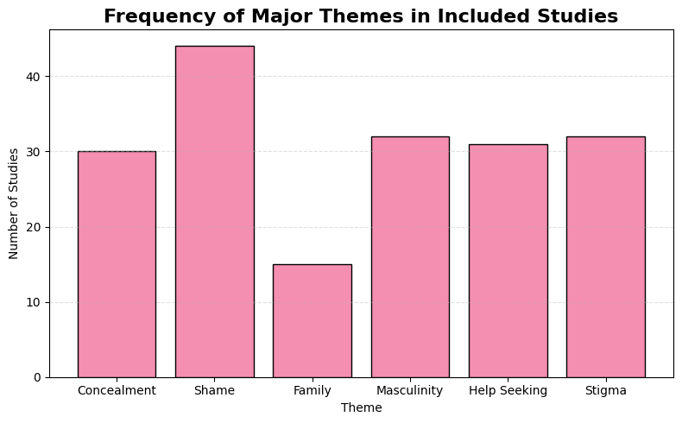
4.1.7 Frequency of major themes
This figure presents major themes associated with the dataset. Shame was one of the most identified themes appearing in 44 studies, thus it is one of the most consistent factors in males. Masculinity and stigma were identified in 32 studies. Help seeking in 31 studies. Concealment occurred in 30 studies, demonstrating that the hiding or non-
Figure 8 Frequency of major themes

disclosure of eating disorder symptoms is a commonly reported issue within the literature. Family influence was just found in 15 papers.
These findings indicate that concealment is closely associated with multiple interacting psychosocial factors rather than a single isolated cause.
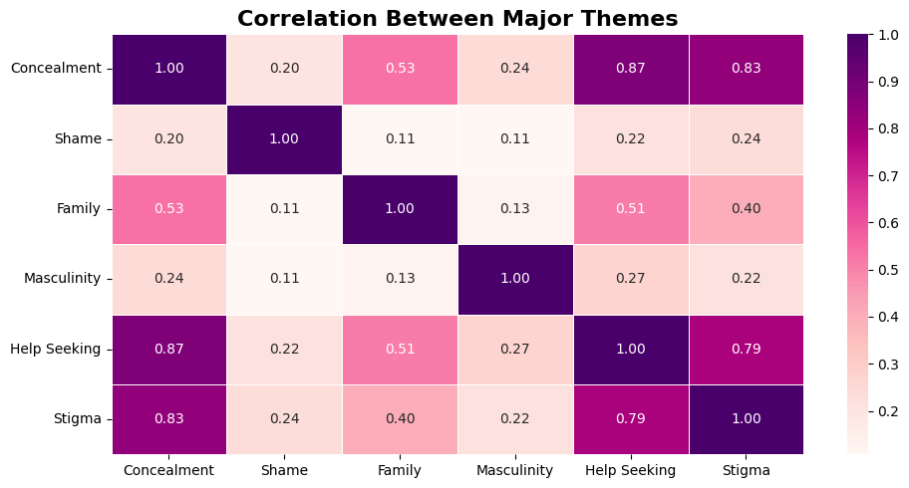
4.1.8 Correlation between major themes
Figure 9 Correlation between major themes
From this figure, we see a positive correlation between concealment and help-seeking barriers (r = 0.87). Thus, studies discussing concealment also had patients having difficulties help-seeking. A similarly strong correlation was observed between concealment and stigma (r = 0.83), suggesting A similarly strong correlation was observed between concealment and stigma (r = 0.83). Moderate positive correlations were identified between concealment and family influences (r = 0.53) and between family influences and help-seeking barriers (r = 0.51). Thus, familial issues might not be such a major factor associated with concealment and help seeking.
In contrast, shame and masculinity demonstrated relatively weak correlations with the remaining themes, with correlation coefficients below 0.30. This doesn’t not mean that its not as prevalent but less likely to be the reason why eating disorder is concealed. Thus, sociocultural stigma and reluctance to seek treatment are central factors contributing to the concealment of eating disorders among males.
4.2 Now, we discuss the bigrams in (i) Analysis of the 50 papers from including regions that are not from South East Asia (ii) Analysis of specifically papers from South East Asia. (iii) Comparison between the two

4.2.1 Analysis of the 50 papers from including regions that are not from South East Asia
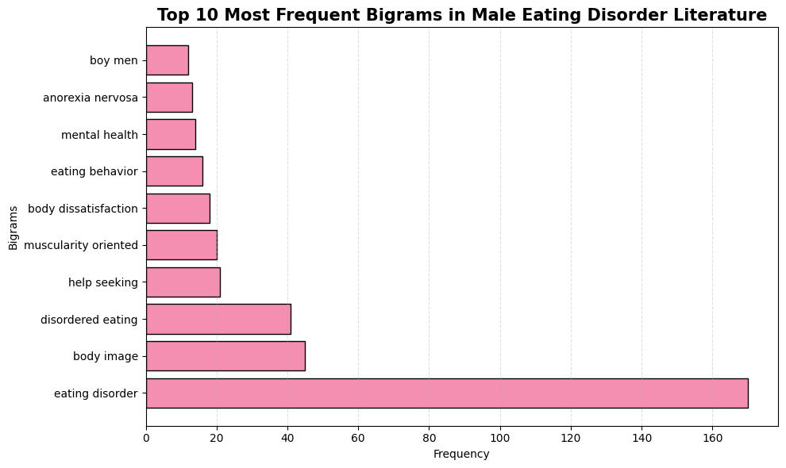
The most common bigram is eating disorder reflecting that it’s in central focus in this dataset. Other frequently occurring bigrams included "body image", "disordered eating", "help seeking", "muscularity oriented", "body dissatisfaction",
Figure 10 Analysis of the 50 papers from including regions that are not from South East Asia
"Mental health", "anorexia nervosa", "eating behaviour", and "boy men". The prominence of body image, body dissatisfaction, and muscularity-oriented concepts suggests that appearance might be a major factor in these studies. Similarly, the frequent occurrence of help seeking and mental health indicates considerable attention towards psychological wellbeing and barriers to accessing healthcare. Although the general bigram analysis provides an overview of dominant concepts, it does not specify how these factors are related to concealment.

4.2.2 Analysis of specifically papers from South East Asia.
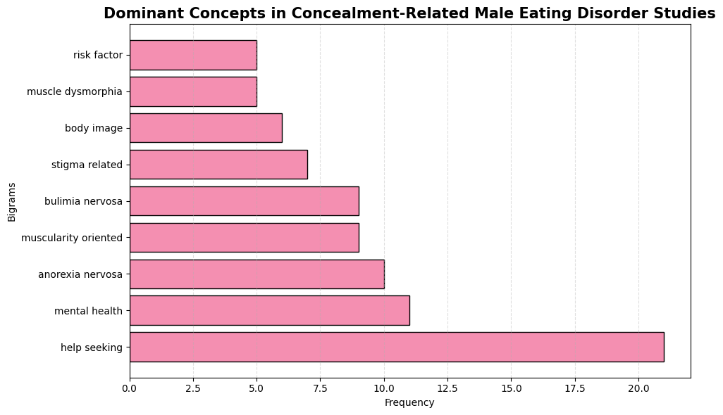
The most prominent bigram was "help seeking" (n = 21) indication discussion related to barriers from seeking professional help. This was followed by "mental health" (n = 11), "anorexia nervosa" (n = 10), "muscularity oriented" (n = 9), "bulimia nervosa" (n = 9), and "stigma related" (n = 7). Additional recurring concepts included "body image", "muscle dysmorphia", and "risk factor". Concealment specific analysis showed a greater number in words such as “help-seeking”, “stigma” and “mental health”. This may suggest that concealment is discussed closely to psychosocial barriers. The persisting occurrence of body image, muscularity-related and muscle dysmorphia reveals that male-specific body image is still an essential factor to consider when trying to understand why eating disorders are concealed. In general, these results show that concealment in males is highly linked to help-seeking behaviour, stigma and psychological well-being. This shift in word distribution shows that once researchers start discussing concealment, we slowly shift to the factors behind concealment instead of talking about the disorder. This suggests they are closely related to each other.
Figure 11 Bigram of concealment specific dataset
4.2.3 Comparison between the two bigrams
Thus, we notice a distinct shift from the dominant concepts discussed in the two bigrams. Whilst the general full corpus bigram (50 studies) leaned towards "eating disorder," "body image," "disordered eating," "mental health," and "anorexia nervosa."; the concealment-specific bigram (30 studies) transitions to “help-seeking”, “muscularity-oriented” and “stigma-related” terms. Thus, it shows a shift into the psychosocial factors into why eating disorders is concealed in males. We notice that “stigma-related” appeared only in the later bigram re-enforcing that it is one of the major factors behind concealment as seen in the correlation analysis. Similarly, the prominence of “help seeking” in the concealment corpus indicates that reluctance to access professional support is a defining feature of concealment rather than of the broader eating disorder literature. This might be one of the pieces of evidence that concealment and factors behind concealment is closely related and discussed as a consequence of interacting psychosocial factors rather than the clinical characteristics of the disorder itself.
Table 1 Comparison between the two bigrams
General Bigram Analysis (50 Papers) | Concealment-Specific Bigram Analysis (30 Papers)
Focuses on eating disorders in general | Focuses specifically on concealment
Dominated by "eating disorder" | Dominated by "help seeking"
Emphasises diagnosis and body image | Emphasises barriers to disclosure and treatment
Clinical concepts are more common | Psychosocial concepts are more common
Body image and disordered eating are prominent | Stigma, help-seeking, and mental health become more prominent
Describes the disorder | Explains why the disorder remains hidden

4.3 Although bigram analysis provides us an overview of the dominant concepts, it does not actually provide us an idea of the context of how its discussed. Therefore, Keyword-in-Context (KWIC) analysis was performed in the concealment specific dataset to examine the contextual usage of the major themes identified through both thematic coding and bigram analysis.
4.3.1 Key word – help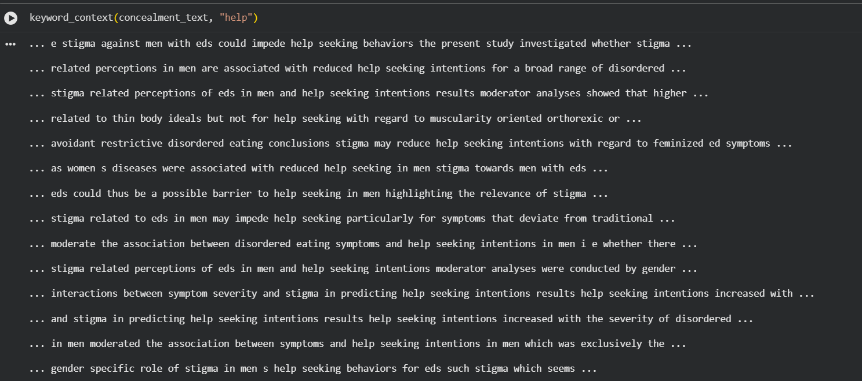

Figure 12 screenshot from Google Colab
From a qualitative insight we see that “help” was closely related to stigma, cultural norms, barriers to treatment. Most contextual excerpts indicated that stigma toward men with eating disorders reduced help-seeking intentions, discouraged disclosure, and delayed access to professional care. We also see those traditional norms and the perception of eating disorder as a feminine illness created barriers in diagnosis. Thus, the contextually analysis showed that help seeking and stigma are one of the most frequently occurring concepts within concealment-related studies. A screenshot is provided to see the overview of the words associated. Feel free to run the code after uploading the dataset provided.
4.3.2 Key word – stigma
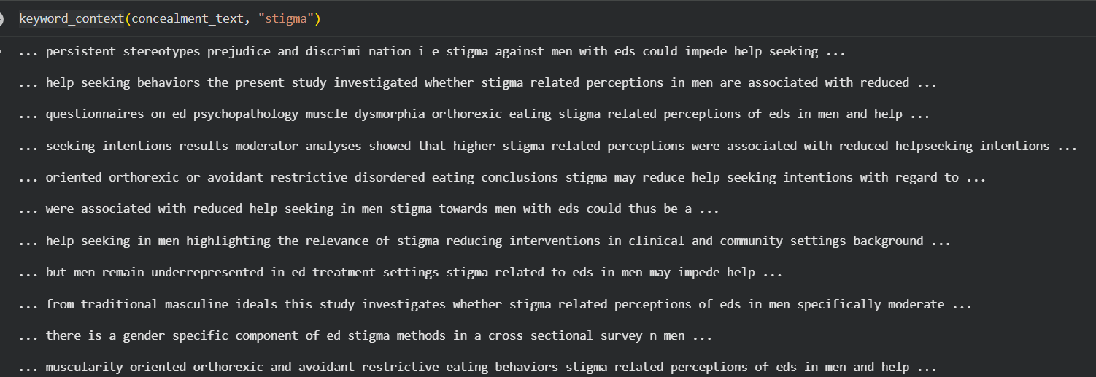
Figure 13 screenshot from Google Colab
We notice that stigma consistently reduced help-seeking intentions among males with eating disorder. Factors such as assuming that eating disorder is a feminine illness caused a significant delay in diagnosis. Traditional masculine ideals reinforced the concept of stigma. Cultural attitude and discrimination are also identified along with stigma. Several studies recommended stigma-reduction programmes and culturally sensitive interventions to improve early recognition and healthcare access.
4.3.3 Key word -Shame
Figure 14 screenshot from Google Colab
We notice that shame is not discussed in context to concealment. Although shame emerged as a prominent theme during the manual thematic coding (93.3% of studies), it was not explicitly used as a recurring keyword in the abstracts. Instead, the concept appears to have been discussed indirectly through related constructs such as stigma, help-seeking barriers, and traditional masculine norms.
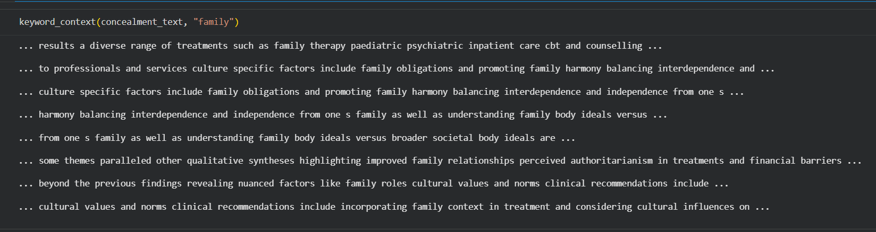
4.3.4 Key word – family

Figure 15 Screenshot from Google Colab

This analysis suggests that the term family was associated with of family obligations, family harmony, family relationships, family roles, and family body ideals rather than as a direct cause of concealment. Cultural values and family expectations influenced disclosure and treatment. Family context was also frequently discussed in relation to treatment approaches. These findings suggest that family functions as an important sociocultural influence that shapes attitudes toward eating disorders.
4.3.5 Key word - masculinity
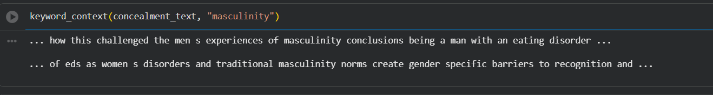
Figure 16 Screenshot from Google Colab
The keyword-in-context analysis of the word “masculinity” revealed that the concept of masculinity is mainly associated with traditional masculine traits and men’s experience of having an eating disorder. The extracted contexts reveal that eating disorders tend to be considered diseases of women, resulting in unique difficulties in recognizing, disclosing, and diagnosing eating disorders in men. It was found that traditional masculine traits hinder men from demonstrating emotional vulnerability and seeking help, which leads to the hiding of signs of an eating disorder.
5.1 Conclusion
From the current study, it can be seen that concealment of eating disorders in men is consistently linked to certain psychosocial factors. The thematic coding showed stigma, shame, masculinity, help-seeking behaviour, and family as the recurring factors in the literature. Moreover, there was a significant correlation between concealment and help-seeking barriers and stigma. Computationally, these results were also supported, as the concealment corpus included fewer clinical terms and more psychosocial factors including help-seeking, stigma, and psychological well-being of individuals. Lastly, this indicated that all of these factors had been discussed in relation to delays in disclosure, help-seeking, masculine norms, and cultural practices.

6.1 References
- https://meddocsonline.org/journal-of-psychiatry-and-behavioral-sciences/malays-and-eating-disorders-in-Singapore-A-potential-ethnic-risk-in-a-Southeast-Asian-society.html
- https://www.psychiatry.org/patients-families/eating-disorders/what-are-eating-disorders#:~:text=Eating%20disorders%20involve%20a%20disordered,laxative%20misuse%2C%20or%20excessive%20exercise.
- https://www.sciencedirect.com/science/article/pii/S0165032725010389
- https://www.allianceforeatingdisorders.com/why-early-intervention-matters-the-first-signs-of-an-eating-disorder/#:~:text=Preventing%20Physical%20and%20Psychological%20Damage,eating%20disorders%20can%20be%20severe.
- https://archeroracle.org/98507/opinion/op-ed-instagrams-role-in-the-growing-rates-of-eating-disorders-in-teenagers/
- https://anad.org/eating-disorders-in-east-asian-populations/
- https://mider.openrepository.com/server/api/core/bitstreams/33d30099-e356-4551-9e84-322a718bbf9a/content
- https://link.springer.com/article/10.1007/s40519-025-01746-z
The dataset of the 50 papers is attached with this document.
Github

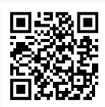
LinkedIn
https://www.linkedin.com/in/shalini-roy-2859ba331/

